WFUMB Image of the Month – Template
Instructions for contributors

Please provide:

1. A single image or series of images or video illustrating the case
2. A brief description of the clinical background relevant to the image(s) (maximum 150 words)
3. A question based on the case and image(s) – this may be diagnostic, educational, or about management
4. Images courtesy of: the contributor's name and institution

Alternative format: You may submit a sequence of 2–3 questions, each accompanied by an image or set of images. Each stage should build on the previous question and images, with all material relating to the same case or patient.

File formats: Images may be submitted in PNG, TIFF, JPG or JPEG format. Video content may be submitted in MP4, MOV, AVI or WebM format.

Example of a completed submission
- Images

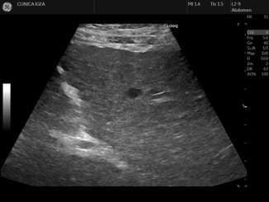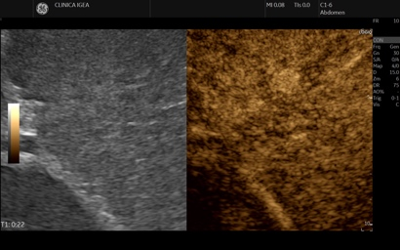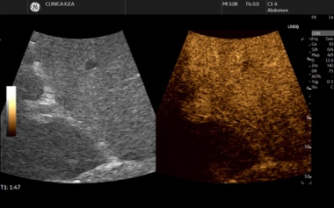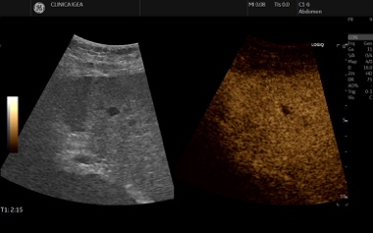
Fig 1. B-Mode Fig 2. Arterial phase Fig 3.Portal phase Fig 4 Late phase

(Insert here a single image or series of images illustrating the case)

2. Clinical background (max 150 words)
A 62-year-old man with a history of hepatitis C virus-related cirrhosis (Child-Pugh A) underwent surveillance ultrasound, which detected a 10-mm hypoechoic nodule in segment VI. The nodule was not clearly characterized on B-mode. Triphasic CT showed a lesion with indeterminate features, classified as LR-4 according to CT/MRI LI-RADS v2018. The patient was referred for CEUS for further characterization.

3. Question

Based on the CEUS findings, what is the most likely diagnosis?

A) Hemangioma
B) Hepatocellular carcinoma
C) Intrahepatic cholangiocarcinoma
D) Focal nodular hyperplasia

(Correct answer: B. The nodule shows arterial phase hyperenhancement followed by mild and late washout, consistent with CEUS LR-5, highly specific for HCC.)

4. Images courtesy of

Dr. M. Franca Meloni, Department of Radiology, [Caso di Cura Igea], Italy.

Alternative format – Sequential questions
Question 1 – Based on the B-mode image, how would you characterize this nodule?

Question 2 – After contrast administration, what is the enhancement pattern in the arterial phase?

Question 3 – Based on the complete CEUS pattern, what is the most likely diagnosis and how would you manage the patient?

Contributor checklist
□ Image or video attached (PNG, TIFF, JPG, JPEG, MP4, MOV, AVI or WebM)
□ Clinical background ≤ 150 words
□ Question(s) included (diagnostic, educational, or management)
□ Correct answer provided
□ Contributor name and institution included
□ Consent for publication obtained, if applicable

